

**Student Project**

**Healthcare Analytics**

**Garbhagudi IVF center-Data Analysis**

Contents

PROJECT COVER SHEET 2

BACHGROUND 3

SCOPE OF IVF ORGANISATION 3

OBJECTIVES OF IVF ORGANISATION 3

FLOW OF IVF COST ANALYSIS 4

FLOW OF IVF TREATMENT ANALYSIS 5

PROJECT LIFE CYCLE 6

METRICS 7

RECOMMENDATIONS FOR YOUR ORGANIZATION 9

CONCLUSION 9

INTRODUCTION 10

EXECUTIVE SUMMARY 10

EVOLUTION 10

IVF PROCESS FLOW CHART 12

IUI PROCESS FLOW 14

PROBLEM STATEMENT 16

OBJECTIVES 17

USER SPECIFICATION 18

OVERVIEW 19

THE JOURNEY 19

TREATMENT AVAILABLE IN GGIRHR 19

FUNCTIONAL SPECIFICATIONS 20

TECHNICAL SPECIFICATION: 21

DASHBOARD AND VISUALIZATIONS 22

COUNT OF PATIENTS BY DOCTORS 24

DOCTOR SUCCESS STAGE 25

DISTRIBUTION OF TIME CONCEIVE 26

TOP 10 TEATMENTS ADVISED 27

COUNT OF PATIENTS BY DOCTORS: 28

TREATMENT STATUS 29

DOCTORS SUCCESS STAGES 30

# PROJECT COVER SHEET

|  |  |  |  |
| --- | --- | --- | --- |
| **Project Title** | Analysis of IVF centre - GARBHAGUDI | **Course** | MBA BA I Year – III Trimester |
| **Start Date** | 01-06-2024 | **Guide/Client** | Dr. Lakshmi Venkatesh |
| **End Date** | 30-07-2024 | **Faculty** | E.L.Sastry & Dr.Mansoor |

**Team Members**

|  |  |  |
| --- | --- | --- |
| **SNO** | **Name** | **Roll Number** |
|  | VELATI APOORVA | 23MG202A31 |

# BACHGROUND

## SCOPE OF IVF ORGANISATION

* Provide comprehensive IVF services, including egg and sperm freezing, embryo transfer and diagnostic services, including semen analysis, embryo biopsy, genetic testing.
* Conduct research in areas such as embryo development, genetic testing and new technologies.
* Provide education and training programs for healthcare professionals, patients and staff.
* Implement quality improvement initiatives to ensure compliance with regulatory requirements and industry standards.
* Develop and implement marketing and communications strategies to promote the organization's services and reputation.
* Establish partnerships and collaborations with other healthcare organizations, research institutions, and industry partners to advance the field of IVF.

## OBJECTIVES OF IVF ORGANISATION

* Prioritize patient-centered care with individualized treatment plans.
* Focus on improving IVF success rates through investing in cutting-edge research, technology advancements, and skilled medical staff.
* Implement efficient protocols and workflows to reduce wait times and improve treatment efficiency.
* Provide comprehensive education on fertility treatments and processes to empower patients.
* Ensure ongoing training and professional development for clinicians and support staff.
* Develop data-driven insights to monitor and enhance treatment outcomes and operational efficiency.

## 

## FLOW OF IVF COST ANALYSIS

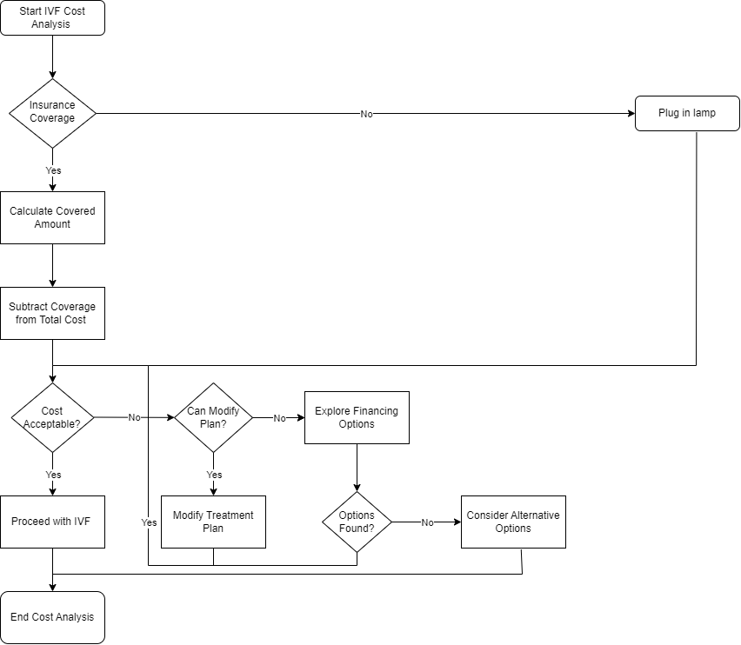

Fig: Flow of IVF cost analysis

## FLOW OF IVF TREATMENT ANALYSIS

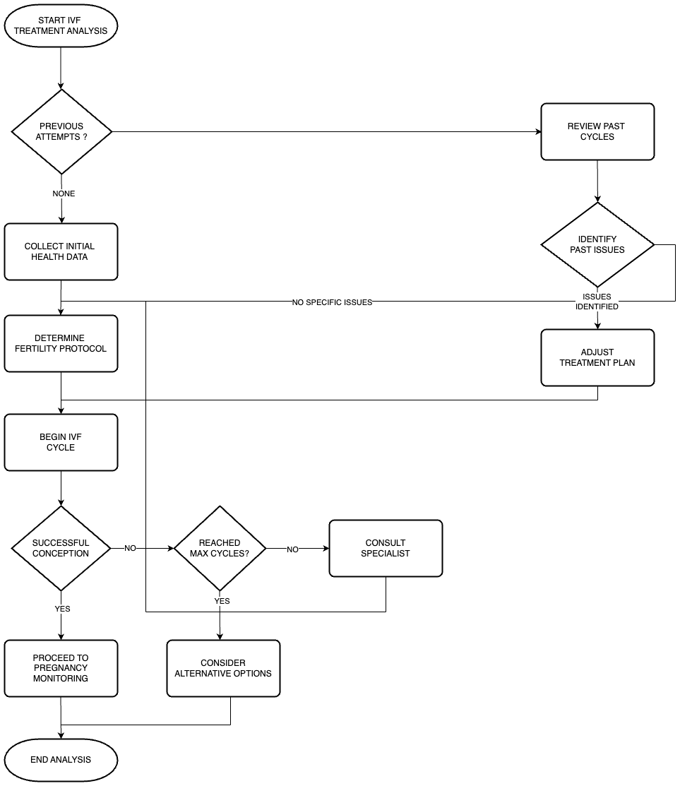

Fig: Flow of IVF treatment analysis

## PROJECT LIFE CYCLE

The project lifecycle ensures a structured approach to analyzing IVF treatment data, leading to accurate, actionable insights and effective decision-making. It guides the project from defining objectives to delivering clear, data-driven recommendations.

## 

## METRICS

**1.Time to Pregnancy (TTP):**

**Definition:** The duration from the start of trying to conceive to achieving pregnancy.

**Importance:** Helps in assessing the effectiveness of fertility treatments and identifying potential issues.

**2.Cycle Monitoring:**

**Definition:** Tracking menstrual cycles to identify ovulation patterns.

**Importance:** Provides insights into the most fertile days and helps in timing intercourse or insemination.

**3.Ovulation Detection:**

**Methods:** Basal body temperature tracking, ovulation predictor kits, and monitoring cervical mucus.

**Importance:** Ensures that intercourse or insemination is timed correctly to increase the chances of conception1**.**

**4.Pregnancy Rate per Cycle:**

**Definition:** The percentage of cycles that result in pregnancy.

**Importance:** Measures the success rate of fertility treatments or natural conception efforts.

**5.Cumulative Pregnancy Rate:**

**Definition:** The total percentage of pregnancies achieved over multiple cycles.

**Importance:** Provides a broader view of fertility treatment success over time.

**6.Live Birth Rate:**

**Definition:** The percentage of pregnancies that result in a live birth.

**Importance:** The ultimate measure of success for fertility treatments.

**7.Miscarriage Rate:**

**Definition:** The percentage of pregnancies that end in miscarriage.

**Importance:** Helps in understanding and addressing potential issues in maintaining pregnancy.

**8.Cost per Pregnancy:**

**Definition:** The total cost of fertility treatments divided by the number of pregnancies achieved.

**Importance:** Evaluates the financial efficiency of fertility treatments.

## RECOMMENDATIONS FOR YOUR ORGANIZATION

1. **Enhance Doctor Collaboration:** Investigate the success rates across doctors to identify any best practices that can be shared to standardize higher success rates.
2. **Address Bottlenecks:** Focus on patients who are awaiting further actions. Streamlining this process could increase overall success rates and patient satisfaction.
3. **Resource Allocation:** Allocate more resources during peak months (e.g., March and April) to ensure that both patient volume and treatment success are maximized.
4. **Dropout Analysis:** Conduct exit interviews or surveys to understand why patients drop out and how these issues can be addressed to reduce churn.
5. **Diversify Specializations:** Invest in underperforming specializations like gynecology and laboratory services to potentially attract more patients beyond just reproductive health.

## CONCLUSION

Provides an overview of key metrics and success stages at an IVF center, highlighting the number of doctors available, specializations covered, and patient distribution. It emphasizes the need to standardize successful practices among doctors, analyze monthly fluctuations in pregnancy rates, address patient dropouts, and optimize resource allocation. The dashboard graphs depict patient distribution among doctors, doctor success stages, time to conceive distribution, top advised treatments, and treatment status, offering insights into patient flow, treatment efficacy, and common treatment recommendations. Additionally, the document includes recommendations to enhance doctor collaboration, address bottlenecks, allocate resources efficiently, analyze patient dropouts, and diversify specializations to attract more patients.

# 

# INTRODUCTION

## EXECUTIVE SUMMARY

* Provides key metrics: doctor success stages, pregnancy rate, treatment plan distribution, and pregnancy status breakdown.
* Recommendations: enhance doctor collaboration, address patient treatment bottlenecks, allocate resources, analyze patient dropouts, and diversify specializations.
* Graphs depict patient distribution, doctor success stages, time to conceive, top treatments, and treatment status.
* Action points: standardize successful practices, analyze factors contributing to success rates, ensure efficient patient interventions, and expand marketing efforts.

## 

## EVOLUTION

The evolution of In Vitro Fertilization (IVF) began with the basic idea of helping couples with fertility issues conceive. Here's a detailed yet simple breakdown:

**Early Concepts (1800s-1950s)**

* **Early theories**: The idea of fertilizing an egg outside of the body was proposed in the late 1800s, though it wasn’t fully understood.
* **Animal research**: By the 1950s, scientists successfully fertilized eggs from rabbits and mice outside of the body (in vitro, meaning "in glass").

**Breakthrough Moment (1960s-1970s)**

* **First human IVF attempts**: In the 1960s, doctors began trying to fertilize human eggs in the lab. Early efforts often failed, but this paved the way for future breakthroughs.
* **Landmark success**: In 1978, the first baby conceived through IVF, Louise Brown, was born in the UK. This was a significant scientific achievement as it proved IVF could work in humans.

**Initial Procedures (1980s)**

* **Basic IVF process**: Early IVF involved stimulating the ovaries to produce multiple eggs, retrieving them, fertilizing them with sperm in a lab, and transferring the resulting embryos into the uterus.
* **Success rates**: In the early days, IVF success rates were low—often around 10-15%. But as doctors gained experience, success rates began to improve.

**Refinements & Growth (1990s-2000s)**

* **Embryo freezing**: In the 1990s, advancements in freezing embryos (cryopreservation) allowed couples to store embryos for future use, significantly improving treatment flexibility and outcomes.
* **ICSI (Intracytoplasmic Sperm Injection)**: Introduced in the 1990s, ICSI allowed doctors to inject a single sperm directly into an egg. This was a game-changer for male infertility, which was a key factor in many couples’ infertility.
* **Preimplantation genetic testing (PGT)**: This allowed screening of embryos for genetic abnormalities before implantation, improving the likelihood of healthy pregnancies.

**Recent Advances (2010s-Present)**

* **Improved success rates**: By the 2010s, IVF success rates had improved significantly, especially as labs optimized conditions for embryo growth. Clinics started personalizing treatment based on patient profiles.
* **Egg freezing**: A major advance in fertility preservation, egg freezing has allowed more people to delay childbearing until later in life.
* **Advances in genetic screening**: Genetic testing has become more precise, allowing for better selection of embryos free from certain genetic disorders.

## IVF PROCESS FLOW CHART

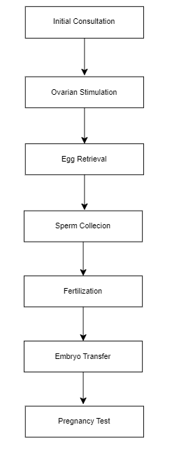

Fig : IVF Process flow

Description:

1.Initial Consultation

* Meet with a fertility specialist.
* Discuss medical history and treatment options.

2.Ovarian Stimulation

* Administer fertility medications.
* Monitor follicle development with ultrasounds and blood tests.

3.Egg Retrieval

* Perform minor surgical procedure to collect eggs.
* Use ultrasound guidance to retrieve eggs from ovaries.

4.Sperm Collection

* Collect sperm sample from partner or donor.
* Prepare sperm for fertilization.

5.Fertilization

* Combine eggs and sperm in a lab.
* Monitor fertilization and embryo development

6.Embryo Transfer

* Select the best embryos.
* Transfer embryos into the uterus.

7.Pregnancy Test

* Conduct blood test to check for pregnancy.
* Monitor early pregnancy development.

EVOLUTION OF IUI (INTRAUTERINE INSEMINATION)

* 1980s: IUI introduced as a less invasive and less expensive alternative to IVF
* 2000s: New sperm preparation techniques and ovulation induction agents improve success rates
* 2010s: IUI becomes a popular treatment option for unexplained infertility, mild male factor infertility, and mild endometriosis
* Present day: Advanced sperm preparation techniques, ovulation induction agents, and new protocols improve success rates
* Future directions: AI, machine learning, and new sperm preparation techniques may further improve IUI success rates

## IUI PROCESS FLOW

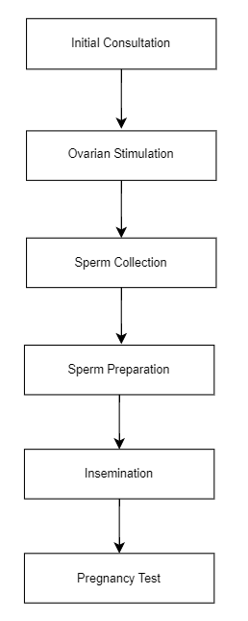

Fig : IUI Process flow chart

Description:

1.Initial Consultation

* Meet with a fertility specialist.
* Discuss medical history and treatment options.

2.Ovarian Stimulation

* Administer fertility medications.
* Monitor follicle development with ultrasounds and blood tests.

3.Sperm Collection

* Collect sperm sample from partner or donor.
* Prepare sperm for insemination.

4.Sperm Preparation

* Wash and concentrate sperm sample.
* Remove seminal fluid.

5.Insemination

* Insert a thin catheter through the cervix into the uterus.
* Inject the prepared sperm sample.

6.Pregnancy Test

* Conduct blood test to check for pregnancy.
* Monitor early pregnancy development.

# PROBLEM STATEMENT

A. Cost to Conceive:

Self-Cycles: Analyze the total cost incurred for patients undergoing IVF using their own Oocytes.

* Patients opting for IVF using their own oocytes can expect to incur costs including various components such as initial consultations, medications for ovarian stimulation, regular ultrasounds to monitor follicular development, the egg retrieval procedure, fertilization, and the embryo transfer process. Additional costs may arise from genetic testing or additional treatments if required.

Donor Cycles: Analyze the total cost incurred for patients undergoing IVF using donor Oocytes.

* For those using donor oocytes, the higher cost is attributed to the additional expenses related to donor compensation, thorough screening, and the matching process. Donor cycles also include all the standard IVF procedures such as egg retrieval (from the donor), fertilization, and embryo transfer.

B. Time to Conceive:

Self-Cycles: Calculate the average time taken for patients to conceive using their own Oocytes.

* The average time taken to conceive using self-oocytes varies depending on individual circumstances. On average, it may take around 3-6 months for a successful pregnancy, factoring in the time for multiple IVF cycles if necessary. The patient's age, health condition, and egg quality play significant roles in this timeframe.

Donor Cycles: Calculate the average time taken for patients to conceive using donor Oocytes.

* Conception using donor oocytes generally results in a shorter time to pregnancy, typically around 2-4 months. This is due to the generally higher quality of donor eggs, which increases the likelihood of successful fertilization and implantation in the first few cycles.

C. Price per Cycle:

Self-Cycles: Determine the cost per cycle for patients using their own Oocytes.

* The cost per IVF cycle using own oocytes includes cost consultations, medications, ultrasounds, egg retrieval, fertilization, and embryo transfer. The exact cost can vary based on the individual treatment protocol and any additional treatments required.

Donor Cycles: Determine the cost per cycle for patients using donor Oocytes.

* For donor oocyte cycles, the cost includes donor compensation, screening, and all the standard IVF procedures.

## OBJECTIVES

A. Time to conceive:(Understand and optimize the timing for conception.)

* Minimize the time to achieve pregnancy through advanced diagnostic tools and treatments.
* Develop personalized treatment plans tailored to individual patient needs and conditions.
* Implement real-time monitoring to adjust treatments promptly.
* Streamline treatment protocols to reduce delays and enhance efficiency.
* Provide comprehensive education and guidance on lifestyle, tracking their menstrual cycles, awareness of changes in cervical mucus and health factors affecting fertility.

B. Cost to Conceive:( Provide transparency regarding the financial aspects of fertility treatments.)

* Discuss the expenses associated with in vitro fertilization (IVF), including fertility medications, genetic testing, and procedures are transparent and clearly communicated to patients.
* Develop flexible payment plans and financing options to make treatments more accessible.
* Optimize resource utilization to reduce overall treatment costs without compromising quality.
* Continuously seek ways to lower costs through bulk purchasing and negotiations with suppliers.

C. Price per Cycle:(Calculate the overall price incurred per treatment cycle.)

* Create standardized pricing models for different treatment cycles to ensure consistency.
* Offer comprehensive treatment packages that cover all necessary procedures ,follow-up care ,nutritional counseling and stress management with discounts for multiple cycles to ensure better value for patients.
* Continuously improve operational efficiency to reduce costs and maintain competitive pricing.

## USER SPECIFICATION

The system shall be designed to meet the needs of the following user groups:

1. **Administrators**:

* Shall be able to access and manage the system, including adding new users and assigning roles.
* Shall be able to configure the system settings, including data sources and dashboard layouts.

1. **Clinicians**:

* Shall be able to view and analyse the data, including KPIs and trends.
* Shall be able to use the dashboards to inform treatment decisions and improve patient outcomes.

1. **Patients**:

* Shall be able to view their own data, including treatment history and outcomes.
* Shall be able to use the system to track their progress and communicate with clinicians.

# 

# OVERVIEW

## THE JOURNEY

GarbhaGudi Institute of Reproductive Health & Research (GGIRHR), founded in 2018, emerged with a vision to revolutionize infertility education. Led by specialists like Dr. Asha S Vijay, GGIRHR offers advanced fellowship courses and short-term training recognized by medical associations. Their focus on comprehensive reproductive medicine training bridges the gap in infertility care. With expert faculty, research initiatives, and ethical practices. GGIRHR aims to address the shortage of trained clinicians, embryologists, and support staff in infertility treatment. GGIRHR continues to empower professionals worldwide.

## TREATMENT AVAILABLE IN GGIRHR

In Vitro Fertilization (IVF):

* IVF involves fertilizing eggs with sperm outside the body and transferring the resulting embryos into the uterus. GGIRHR provides hands-on IVF training and fellowship programs for postgraduate doctors.

Intrauterine Insemination (IUI):

* IUI is a simpler fertility treatment where prepared sperm is directly placed into the uterus during the woman’s fertile window. GGIRHR offers training in IUI techniques.

Embryo Transfer Techniques:

* GGIRHR covers various embryo transfer methods, including fresh and frozen cycles. Training focuses on optimizing embryo implantation.

Ultrasound in Reproductive Medicine:

* GGIRHR provides courses in obstetric ultrasound, allowing clinicians to assess reproductive health through imaging.

Ethical and Economic Implications:

* GGIRHR emphasizes understanding the ethical and economic aspects of infertility treatment. Courses equip professionals with comprehensive knowledge.

Additional Considerations

Success Rates

* GGIRHR is recognized for its high success rates in IVF treatments, which are attributed to its advanced technology, experienced team, and personalized treatment protocols. The institute regularly updates its protocols based on the latest research and innovations in the field of reproductive medicine.

Ethical and Legal Aspects

* GGIRHR maintains stringent ethical standards in all its treatments. The institute has an internal ethical committee that reviews and approves all treatment protocols and research projects to ensure they comply with national and international guidelines. Regular meetings ensure continuous adherence to ethical practices​.

Patient Support

* GGIRHR offers comprehensive support services to patients, including psychological counseling and support groups to help them cope with the emotional aspects of fertility treatments. The institute also provides educational resources, such as workshops and information sessions, to empower patients with knowledge about their treatment options. Financial assistance programs are available to help patients manage the costs of IVF treatments​.

## FUNCTIONAL SPECIFICATIONS

* Patient Management:

Register patients, manage appointments, and track treatment plans.

* Treatment Planning:

Develop and monitor personalized treatment plans.

* Laboratory Services:

Conduct tests, procedures, and maintain equipment.

* Data Management:

Securely store and manage patient data.

* Financial Management:

Handle billing, insurance claims, and track finances.

* Patient Support Services:

Provide counseling, education, and resources.

* Regulatory Compliance:

Ensure adherence to healthcare regulations and standards.

* Quality Assurance:

Monitor and improve service quality and safety.

## TECHNICAL SPECIFICATION:

1. **Programming Languages**:

* The system shall be built using a combination of programming languages, including Python, Excel.

1. **Data Visualization Tools**:

* The system shall use data visualization tools, Power BI.

1. **Database Management System**:

* The system shall use a relational database management system, including Excel.

# DASHBOARD AND VISUALIZATIONS

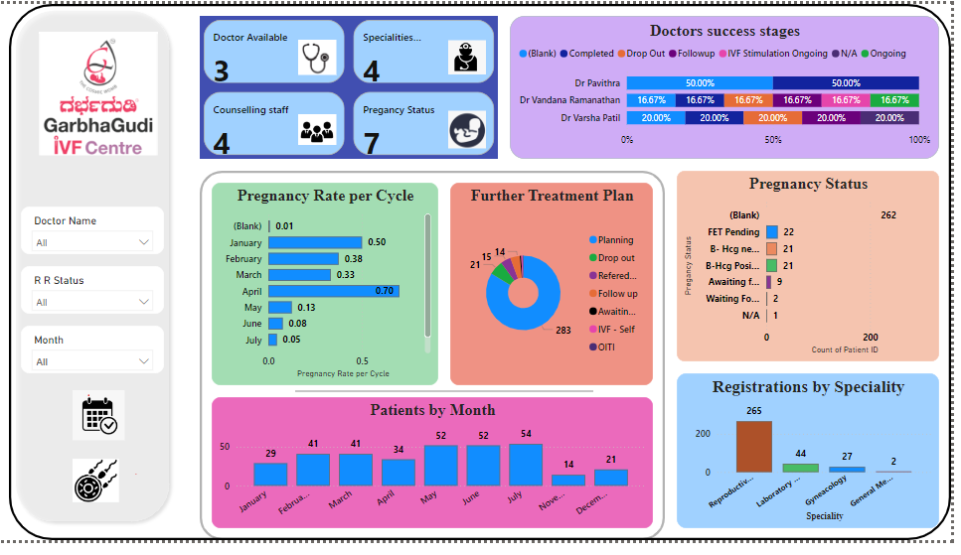

**GarbhaGudi IVF Centre Dashboard**

The dashboard provides a comprehensive visual representation of key performance indicators (KPIs), trends, and metrics relevant to the operations and performance of the GarbhaGudi IVF Centre. It is designed to facilitate quick decision-making and in-depth analysis by stakeholders.

**1. Key Metrics Overview**

* **Doctors Available:** 3
* **Specializations Covered:** 4
* **Counselling Staff:** 4
* **Pregnancy Status Categories Monitored:** 7

**2. Doctors' Success Stages**

* The success rates of doctors vary significantly, with Dr. Pavithra showing a success rate of 50% across different stages, while others show lower performance. This variation could suggest differences in experience or patient treatment approaches.
* Action Point: Consider reviewing and standardizing successful practices among doctors to improve overall outcomes.

**3. Pregnancy Rate per Cycle (Monthly Breakdown)**

* **Highest Pregnancy Rate:** April (0.70 per cycle).
* **Lowest Pregnancy Rate:** June (0.08 per cycle).
* The pregnancy rate shows monthly fluctuations, indicating potential seasonality or other external factors influencing success.
* Action Point: Analyze the factors contributing to higher success rates in months like April and replicate these strategies in less successful months.

**4. Further Treatment Plan Distribution**

* **Largest Group:** 283 patients are in the "Awaiting Further Action" stage, which represents a significant portion of the patient population.
* **Dropouts:** 14 patients have dropped out of treatment, which is a concerning metric.
* Action Point: Ensure efficient and timely interventions to move patients through the treatment process, and address potential reasons behind dropouts.

**5. Pregnancy Status Breakdown**

* **FET Pending:** 22 patients are awaiting Frozen Embryo Transfer, while 21 are awaiting B-HCG (pregnancy confirmation).
* **Action Required:** Timely intervention in these cases is crucial to optimize pregnancy outcomes.

**6. Patients by Month**

* **Patient Volume:** The patient volume is relatively consistent, with a peak in March (52 patients). The lowest patient count is seen in July (14 patients).
* Action Point: Analyze the reasons behind the March peak and explore strategies to increase patient engagement in slower months.

**7. Registrations by Speciality**

* **Dominant Specialty:** Reproductive services lead with 265 registrations.
* **Other Specialties:** Laboratory services (44), gynecology (27), and general medicine (2) have lower patient registration rates.
* Action Point: Consider expanding marketing efforts and improving services in less utilized specialities to increase overall patient intake and diversify services offered.

**Purpose**

The purpose of this dashboard is to provide a holistic view of the IVF centre’s operations, enabling staff and stakeholders to monitor performance, identify trends, and make informed decisions. It serves as a powerful tool for tracking key metrics, understanding patient distribution, and evaluating the success of treatments.

The dashboard depicts the following graphs:

## COUNT OF PATIENTS BY DOCTORS

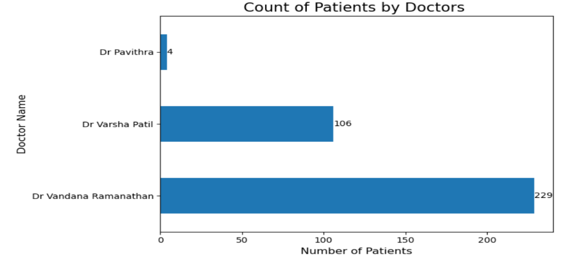

**Title**: Count of Patients by Doctors

**X-axis**: Number of Patients (ranging from 0 to 250, in increments of 50)

**Y-axis**: Doctor Name (listing three doctors: Dr Pavithra, Dr Varsha Patil, and Dr Vandana Ramanathan)

**Main Value**: The highest value is for Dr Vandana Ramanathan, with a count of 229 patients.

**Purpose**: The graph is designed to show the number of patients attended to by each doctor. It provides a clear comparison of patient loads among the three doctors, which can be useful for resource allocation, performance analysis, and identifying workload disparities.

## DOCTOR SUCCESS STAGE

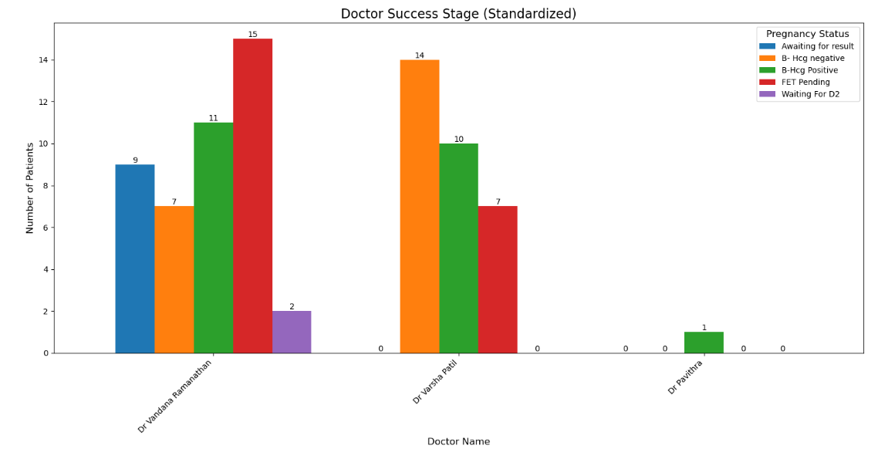

**Title**: Doctor Success Stage

**X-axis**: Stages of the Process

**Y-axis**: Number of Patients

**Purpose**: The graph shows standardized data on patient outcomes at various stages in a medical process related to pregnancy, categorized by their pregnancy status. It helps in understanding which stages have higher numbers of patients in each category, aiding in treatment efficacy and patient flow analysis.

## DISTRIBUTION OF TIME CONCEIVE

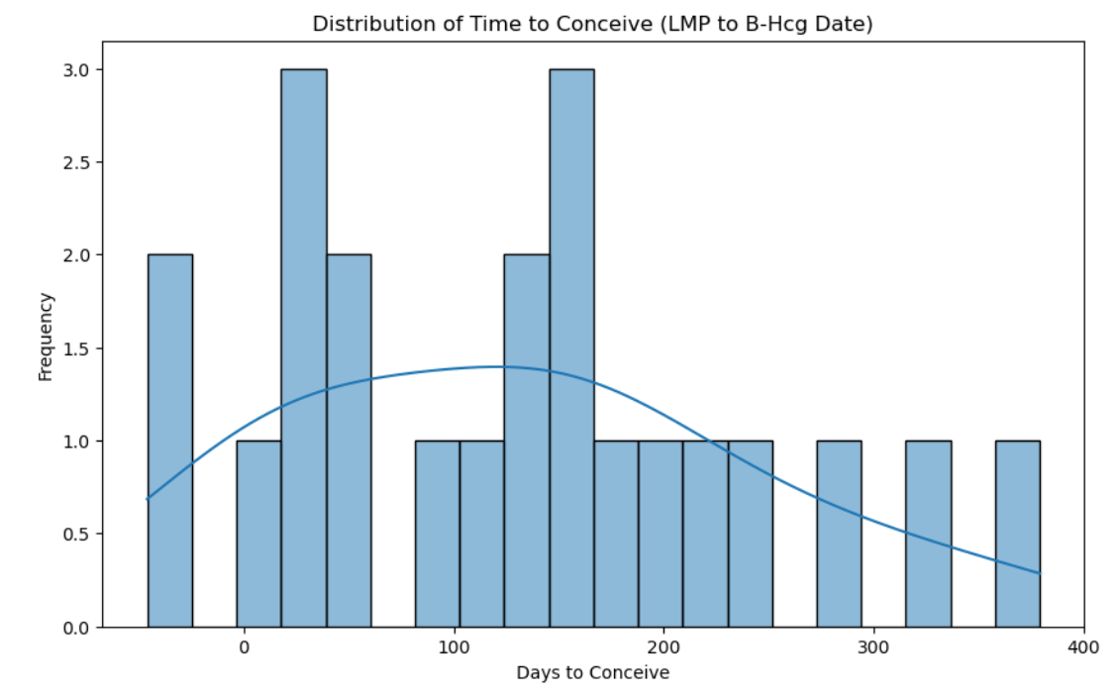

**Title**: Distribution of Time to Conceive

**X-axis**: Days to Conceive

**Y-axis**: Frequency

**Main Value**: The KDE curve peaks between 50 and 100 days, indicating this is the most common time frame for conception in the dataset.

**Purpose**: The graph visualizes the distribution of the time it took for individuals to conceive, measured from the last menstrual period (LMP) to the detection of positive B-Hcg levels. This helps in understanding typical time frames for conception, which can be useful for medical professionals and individuals trying to conceive.

## TOP 10 TEATMENTS ADVISED

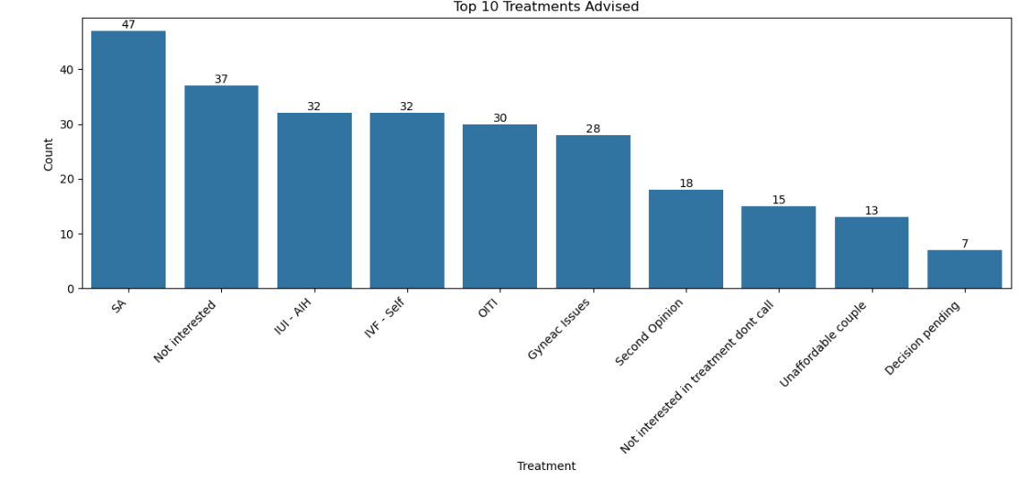

**Title**: Top 10 Treatments Advised

**X-axis**: Treatment (listing the top 10 treatments)

**Y-axis**: Count

**Main Values**: The most advised treatment has a count of 47. The second most advised treatment has a count of 37.

**Purpose**: The graph shows the distribution and frequency of the top 10 treatments advised. It highlights which treatments are most commonly recommended, providing insights into trends or patterns in treatment advice.

## COUNT OF PATIENTS BY DOCTORS:

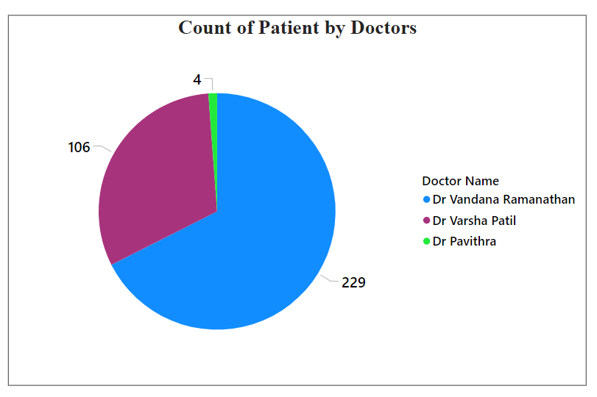

**Title:** Count of Patient by Doctors

**Legend:**

Dr. Vandana Ramanathan (purple)

Dr. Varsha Patil (blue)

Dr. Pavithra (green)

**Main Values:**

* Dr. Vandana Ramanathan: 4 patients
* Dr. Varsha Patil: 106 patients
* Dr. Pavithra: 229 patients

**Purpose:** To visually represent the distribution of patient counts among three different doctors, showing who has seen more or fewer patients.

## TREATMENT STATUS

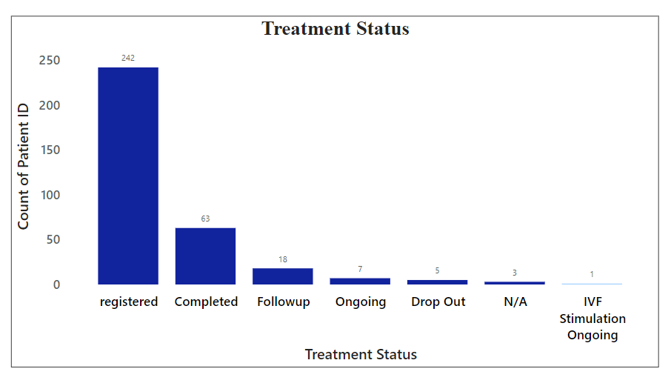

**Title**: Treatment Status

**X-axis**: Treatment Status

**Y-axis**: Count of Patient ID

**Main Values**:

* **Registered**: 242 patients
* **Completed**: 65 patients
* **Follow-up**: 18 patients
* **Ongoing**: 3 patients
* **Drop Out**: 1 patient
* **N/A**: 1 patient
* **IVF Stimulation Ongoing**: 1 patient

**Purpose**: The graph shows the distribution of patients across various stages of a treatment process. It highlights the number of patients in each treatment status, providing insights into patient flow and treatment progress.

## DOCTORS SUCCESS STAGES

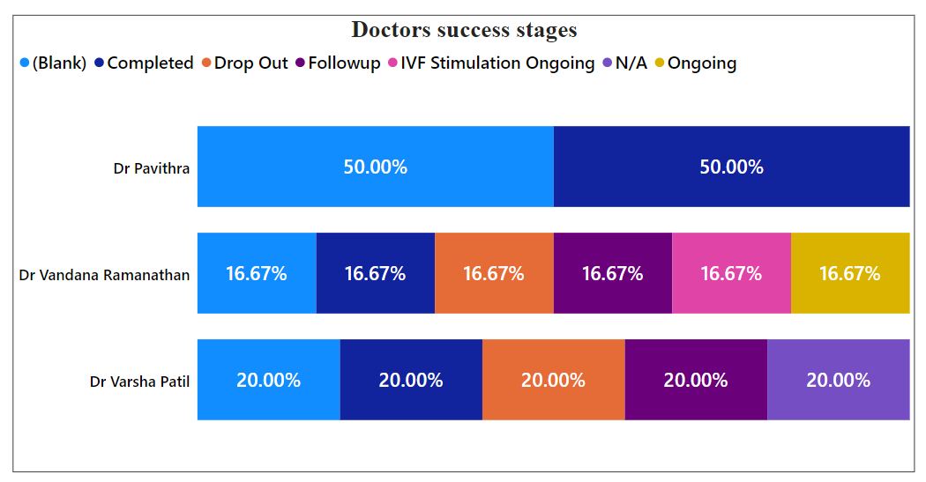

The horizontal bar graph titled “Doctors success stages” shows the distribution of patient outcomes across different stages for three doctors: Dr. Pavithra, Dr. Vandana Ramanathan, and Dr. Varsha Patil.

* Dr. Pavithra: The outcomes are evenly split between Completed and Ongoing stages, each at 50%.
* Dr. Vandana Ramanathan: The outcomes are evenly distributed across all stages (Completed, Drop Out, Follow up, IVF Stimulation Ongoing, N/A, and Ongoing), each at 16.67%.
* Dr. Varsha Patil: The outcomes are evenly distributed across five stages (Completed, Drop Out, Follow up, IVF Stimulation Ongoing, and Ongoing), each at 20%.

The vertical axis depicts three doctors available and the horizontal axis depicts the percentage count success rate at various stages such as Completed, Dropout, Follow up, IVF Stimulation Ongoing, N/A, Ongoing.

**Purpose**: The graph shows the distribution of different stages of success across three doctors’ patient cases. It highlights the proportion of patients in each success stage for each doctor, providing insights into their treatment outcomes.